**Directions**

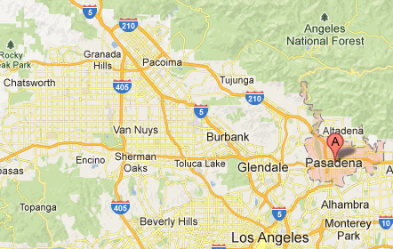

*From the 210 westbound*   
Take the 210 freeway west to the Fair Oaks/Marengo exit. Turn left on Marengo and proceed 4 blocks to Green Street. Turn left onto Green Street, the Pasadena Civic is located on the right hand side at 300 E Green.   
  
*From the 210 southbound*   
Take the 210 freeway south to the Colorado Blvd exit on to St John Ave. Continue south on St John past Colorado Blvd and turn left onto Green Street, travel five blocks east on Green Street. The Pasadena Civic is located on the right hand side at 300 E Green.

*From the 134 eastbound*  
Take the 134 east to the Fair Oaks/Marengo exit. Turn right on Marengo and proceed 4 blocks to Green Street. Turn left onto Green Street and the Pasadena Civic is located on the right hand side at 300 E Green.   
 *From the 110 northbound*  
Take the 110 freeway north to the end of the freeway. The freeway ends at a stoplight. Proceed through the stoplight, you are now on Arroyo Parkway. Exactly one mile from the stoplight you will come to Green Street. Turn right onto Green Street, the Pasadena Civic is located two blocks down on the right hand side at 300 E Green.   
  
*Metro Gold Line to Pasadena*   
(<http://www.metro.net/riding_metro/gold_line.htm>) The Pasadena Civic is located within walking distance of the Memorial Park & Del Mar stations.

**Hotels in the Area**

C:\Documents and Settings\kguilfoil\Local Settings\Temporary Internet Files\Content.IE5\JIE1QJBN\MC900297289[1].wmf

The Westin Pasadena Hotel

Phone: (866) 837-4181

Address: 191 N. Los Robles, Pasadena, 91101

Hilton Pasadena

Phone: (800) HILTONS or (626) 577-1000

Address: 168 S. Los Robles Avenue, Pasadena, CA 91101

The Holiday Inn Express Pasadena Hotel & Suites

Phone: (626) 792-1363

Address: 3500 E. Colorado Blvd., Pasadena, CA 91107

Courtyard By Marriott Pasadena Hotel

Phone: (626) 403-7600

Address: 180 N. Fair Oaks Ave., Pasadena, CA 91103